XC Series PLC C Language Function Block Program

1. New Create A Function Block
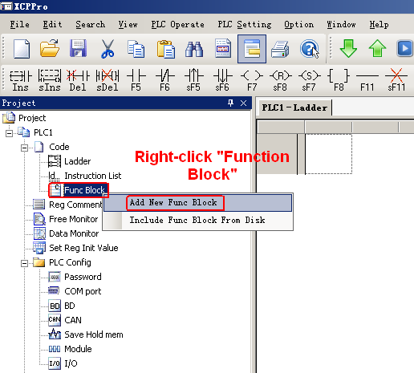

Right click “Func Block”
Choose “Add New Func Block”, the following dialog box will appear:

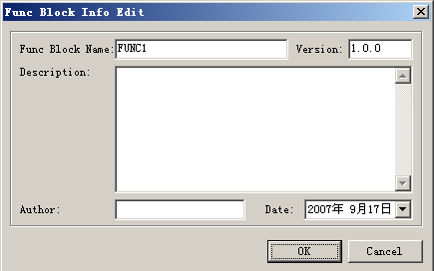
Note:
1.Function Block Name is composed by numeric, English letter and underline, and the firstcharacter shouldn’t be numeric.
2.The name shouldn’t be same with PLC’s system instructions,i.e LD,ADD,SUB,PLSR etc.
3.The name shouldn’t be same with the exist function block name.

After inputing all the information, please click “OK”.

2.Export/import the function block
  - Export the Function Block
Function: Export the function as a file, while other PLC program can use.
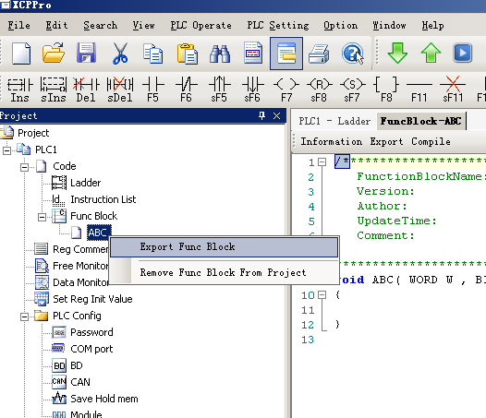
Choose the correspond function block, right click it, select “Export Func Block”, the following interface will appear.

Export Form:
- Editable: export the source code, save as a file. If import again, it can edit once again.
- Not be editable: do not export the source code, if inport again, the file can be used but can not be edited.
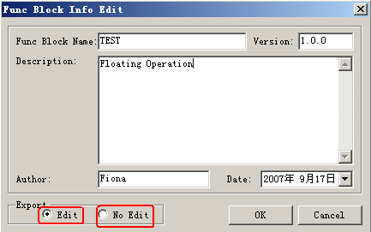
Click “OK”, choose the export path to save.

- Import function block
Function: Import the exsit function block file

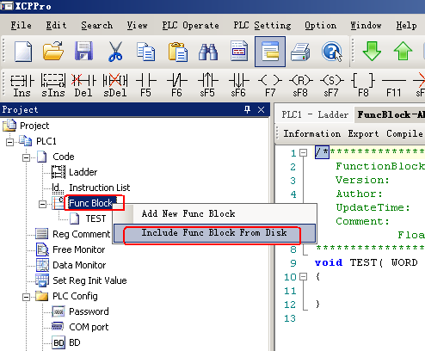
Choose “Func Block”, right click the mouse key, choose “Include Func Block From Disk”, choose the correspond file, click “OK”.

- Remove the Function Block
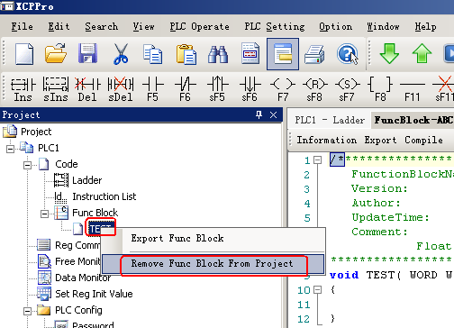

Choose the correspond function block, click “Remove Func Block From Project”.

4. Edit the function block
Example: In the following example, the function is: 1+2+3..+10, then put it in D0
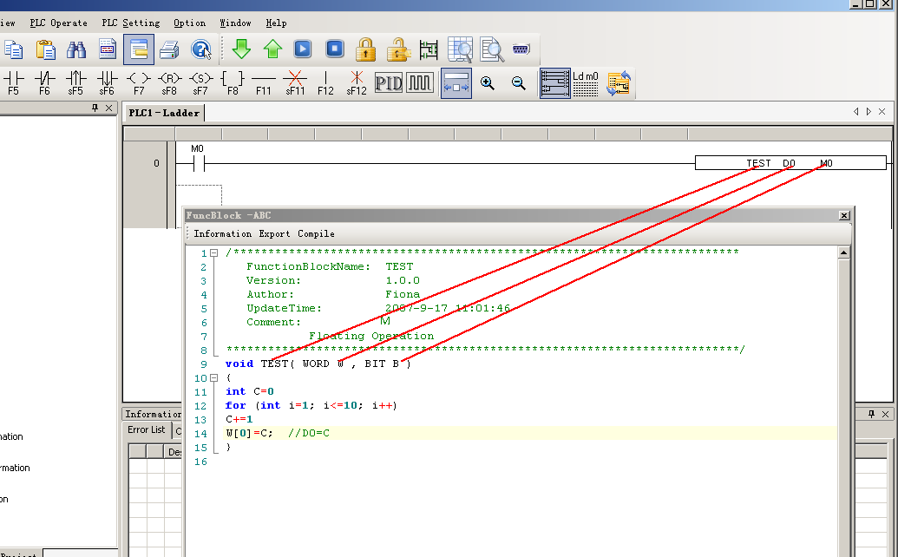

Main Function Name: The function block’s name, this name can’t be changed at your will, you mustchange in the edit window.
Parameters:
WORD W Correspond with “D”
BIT B Correspond with “M”

- Parameters’ transfer Form: When call the function block in the ladder program, the imported D and M are the start address of W and B. For example, start from D0, M0, then W[0] is D0, W[10] is D10, B[0] is M0, B[10] is M10. If in the ladder, it uses parameters as D100, M100, then W[0] is D100, B[0] is M100.
- Parameter W: Means word register, use it in =groups, for example: W[0]=1;W[1]=W[2]+W[3]; in the program, you can use according to C standard.
- Parameter B: Means Bit register, use them in group, support bit ON and bit set, for example: B[0]=1;B[1]=0; and value given, such as B[0]=B[1]
- Double word operation: Add D before W. For example: DW[10]=100000, it means W[10]W[11] combined as a double word.
- Floating Operation: in the function, you can define floating variable, and carry on floating operation.

E.G.
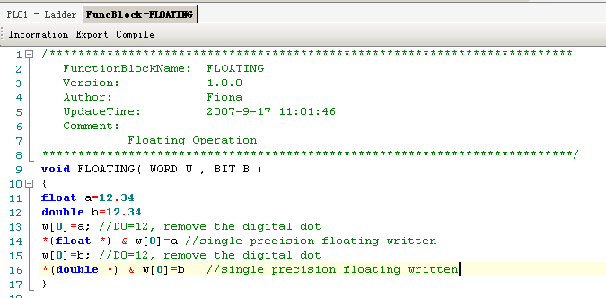
- Function System: The user can use the functions and constants defined in the function system directly. The functions and constants included in the function block are listed in the appendix.
- The other data form supported.
BOOL; // Bool data
INT8U; //8 bits integrator without sign
INT8S; //8 bits integrator with sign
INT16U //16 bits integrator without sign
INT16S //16 bits integrator with sign
INT32U //32 bits integrator without sign
INT32S //32 bits integrator with sign
FP32; //single precision floating
FP64; //Double precision floating

- Pre-defined Macro
#define true 1
#define false 0
#define TRUE 1
#define FALSE 0

5. Notifications:
1.If the PLC program uses function block, after uploading, this function block can not be uploaded. Therewill be an unknown instruction error.
2.In one function block, you can write many subroutines, they can call one another.
3.Each function block file is separte with one another, can not call the self’s function.
- In function block, the file can call floating, arithmetic these C language. Such as sin,cos,tan etc.

Appendix
The Defaulted Function System
Constant Name | Data | Description
_LOG2 | (double)0.693147180559945309417232121458 | Logarithm of 2
_LOG10 | (double)2.3025850929940459010936137929093 | Logarithm of 10
_SQRT2 | (double)1.41421356237309504880168872421 | SQRT 2
_PI | (double)3.1415926535897932384626433832795 | PI
_PIP2 | (double)1.57079632679489661923132169163975 | PI/2
_PIP2x3 | (double)4.71238898038468985769396507491925 | PI*3/2
_D | (double)4.454455103380768678308360248557901415300e-6
_EPS | (double)0.001 /*

String Function
void bcopy(char *,char *, unsigned long);
void bzero(char *,unsigned long);
void * memchr(const void *s, int c, size_t n);
int memcmp(const void *s1, const void *s2, size_t n);
void * memcpy(void *s1, const void *s2, size_t n);
void * memset(void *s, int c, size_t n);
char * strcat(char *s1, const char *s2);
char * strchr(const char *s, int c);
int strcmp(const char *s1, const char *s2);
char * strcpy(char *s1, const char *s2);
数学函数
double acos(double x);
double asin(double x);
double atan(double x);
double atan2(double y, double x);
double ceil(double x);
double cos(double x);
double cosh(double x);
double exp(double x);
double fabs(double x);
double floor(double x);
double fmod(double x, double y);
double frexp(double val, int _far *exp);
double ldexp(double x, int exp);
double log(double x);
double log10(double x);
double modf(double val, double *pd);
double pow(double x, double y);
double sin(double x);
double sinh(double x);
double sqrt(double x);
double tan(double x);
double tanh(double x);
float acosf(float x);
float asinf(float x);
float atanf(float x);
float atan2f(float y, float x);
float ceilf(float x);
float cosf(float x);
float coshf(float x);
float expf(float x);
float fabsf(float x);
float floorf(float x);
float fmodf(float x, float y);
float frexpf(float val, int _far *exp);
float ldexpf(float x, int exp);
float logf(float x);
float log10f(float x);
float modff(float val, float *pd);
float powf(float x, float y);
float sinf(float x);
float sinhf(float x);
float sqrtf(float x);
float tanf(float x);

